Lansing Middle School 5th Grade Supply List
2023-2024
One (1) 1 inch 3 Ring binder for folders. 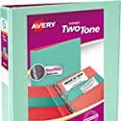

One (1) Fabric Zippered Pencil Case with metal grommets around the holes. 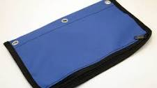

Pencils - sharpened, non-mechanical pencils, replenish throughout the year

Pop-Top Water Bottle

Art - One (1) 9” x 12” white drawing paper, 50 page minimum sketchbook for art. (Sewn bound is preferable. These can be purchased at the school store.)

Art - One 12 piece Crayola Watercolor Colored Pencil set

Clothes for PE - Students should wear sneakers and clothes that are easy to move in on PE days.

Chromebook Mouse (wireless seems to work the best)- OPTIONAL

Headphones (not bluetooth) _Earbud preferred- OPTIONAL

Violin If your child plays a violin, they should have one by September.

